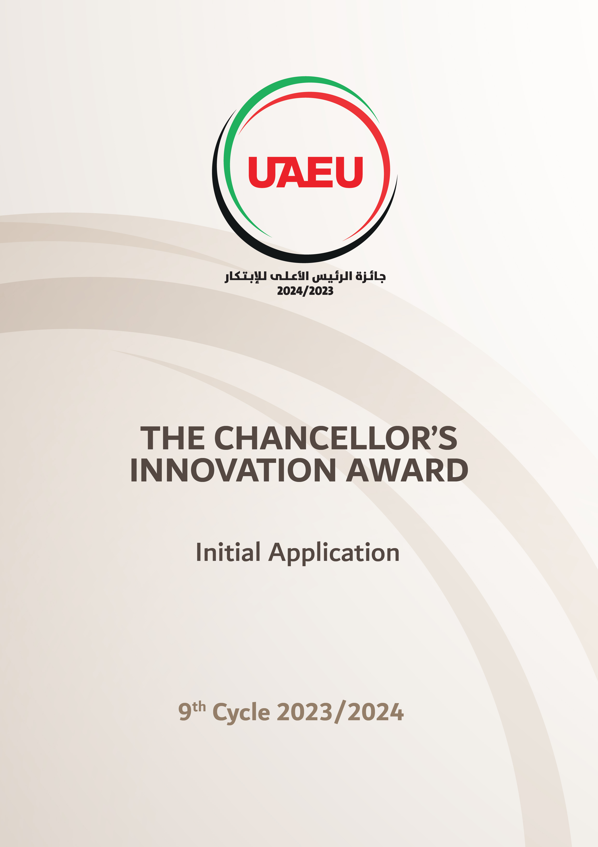

Initial Application Title

Individual/Team Names | UAEU ID# | Competition Area  (Select Only One) | Category  (Select Only One)
1. |  | 1. Climate Change and | Faculty;
2. |  | Environmental Sustainability; 2. | Employees;
3. |  | Renewable Energy; 3. Water and | Students
4. |  | Food Security; 4. Health and
5. |  | Medical Science; 5. Education and
 |  | Lifelong Learning; 6. Space
 |  | Science; 7. Mobility and Urban
 |  | Development; 8. Technology and
 |  | Cyber Security; 9. Social,
 |  | Administrative and Economic
 |  | Growth

The Ninth Cycle - 2023/2024

ABSTRACT

Abstract (Maximum 500 words):
A short description of the idea should be written in lay language that a non-specialist can understand.

Keywords: (3-5 words)

Claims: (Maximum 2 pages)
A list of novel aspects of innovative ideas in the proposed application.

